REAL ESTATE LISTING
@CREATIVITY THINK (9483175986/7019689991)

ABSTRACT:
The Real Estate Listing platform is a web-based application designed to facilitate property sales and rentals by connecting users with agents and brokers efficiently. The system allows users to browse, search, and filter properties, view images and maps, submit contact forms, and schedule property visits. Administrators can add or edit listings, manage agent profiles, handle incoming leads, and monitor analytics through a dashboard. Developed using Django and Django REST Framework for backend operations and React with Leaflet and Axios for frontend interactions, the platform ensures a responsive, interactive, and scalable solution for real estate management..

INTRODUCTION OF THE PROJECT:
Property buying, selling, and renting are often cumbersome without organized digital solutions. Traditional listings lack interactivity, mapping support, and lead management, while agents struggle to track user interests efficiently. The Real Estate Listing platform addresses these challenges by providing a centralized and interactive system for property listings. Users benefit from detailed search, filters, and contact tools, while administrators and agents gain insights into user behavior, leads, and property performance. The combination of Django backend and React frontend ensures secure, fast, and visually rich interfaces for both users and admins..

PROJECT OBJECTIVES:

• Provide a centralized platform for property listing, search, and management.
• Enable users to filter properties by price, location, type, and amenities.
• Display property images, maps, and agent contact details.
• Allow users to submit interest forms and schedule property visits.
• Offer dashboards for administrators to monitor leads, listings, and agent performance.
• Facilitate efficient property and agent management by administrators.
• Ensure scalable, secure, and responsive application architecture.
• Provide analytics insights for better decision-making and reporting.

PROBLEM OF THE STATEMENT:
Traditional real estate listings are often dispersed across multiple platforms with limited interactivity, poor lead management, and no consolidated analytics. Agents and brokers face difficulties in managing listings and tracking client interest efficiently. Users struggle to find relevant properties quickly and coordinate visits. The Real Estate Listing platform solves these problems by offering an interactive search and filter system, integrated maps, contact forms, and a dashboard for administrative oversight and analytics, enabling effective property management and user engagement..

MOTIVATION OF THE PROJECT:
• To digitalize property listings and streamline real estate operations.
• To provide users with an interactive and easy-to-use property search experience.
• To improve lead management and scheduling for agents and brokers.
• To enhance transparency and efficiency in property browsing and transactions.
• To deliver insights and analytics for better business decision-making.
• To create a scalable system suitable for individual agents and large agencies.

BLOCK DAIGRAM OF PROJECT:

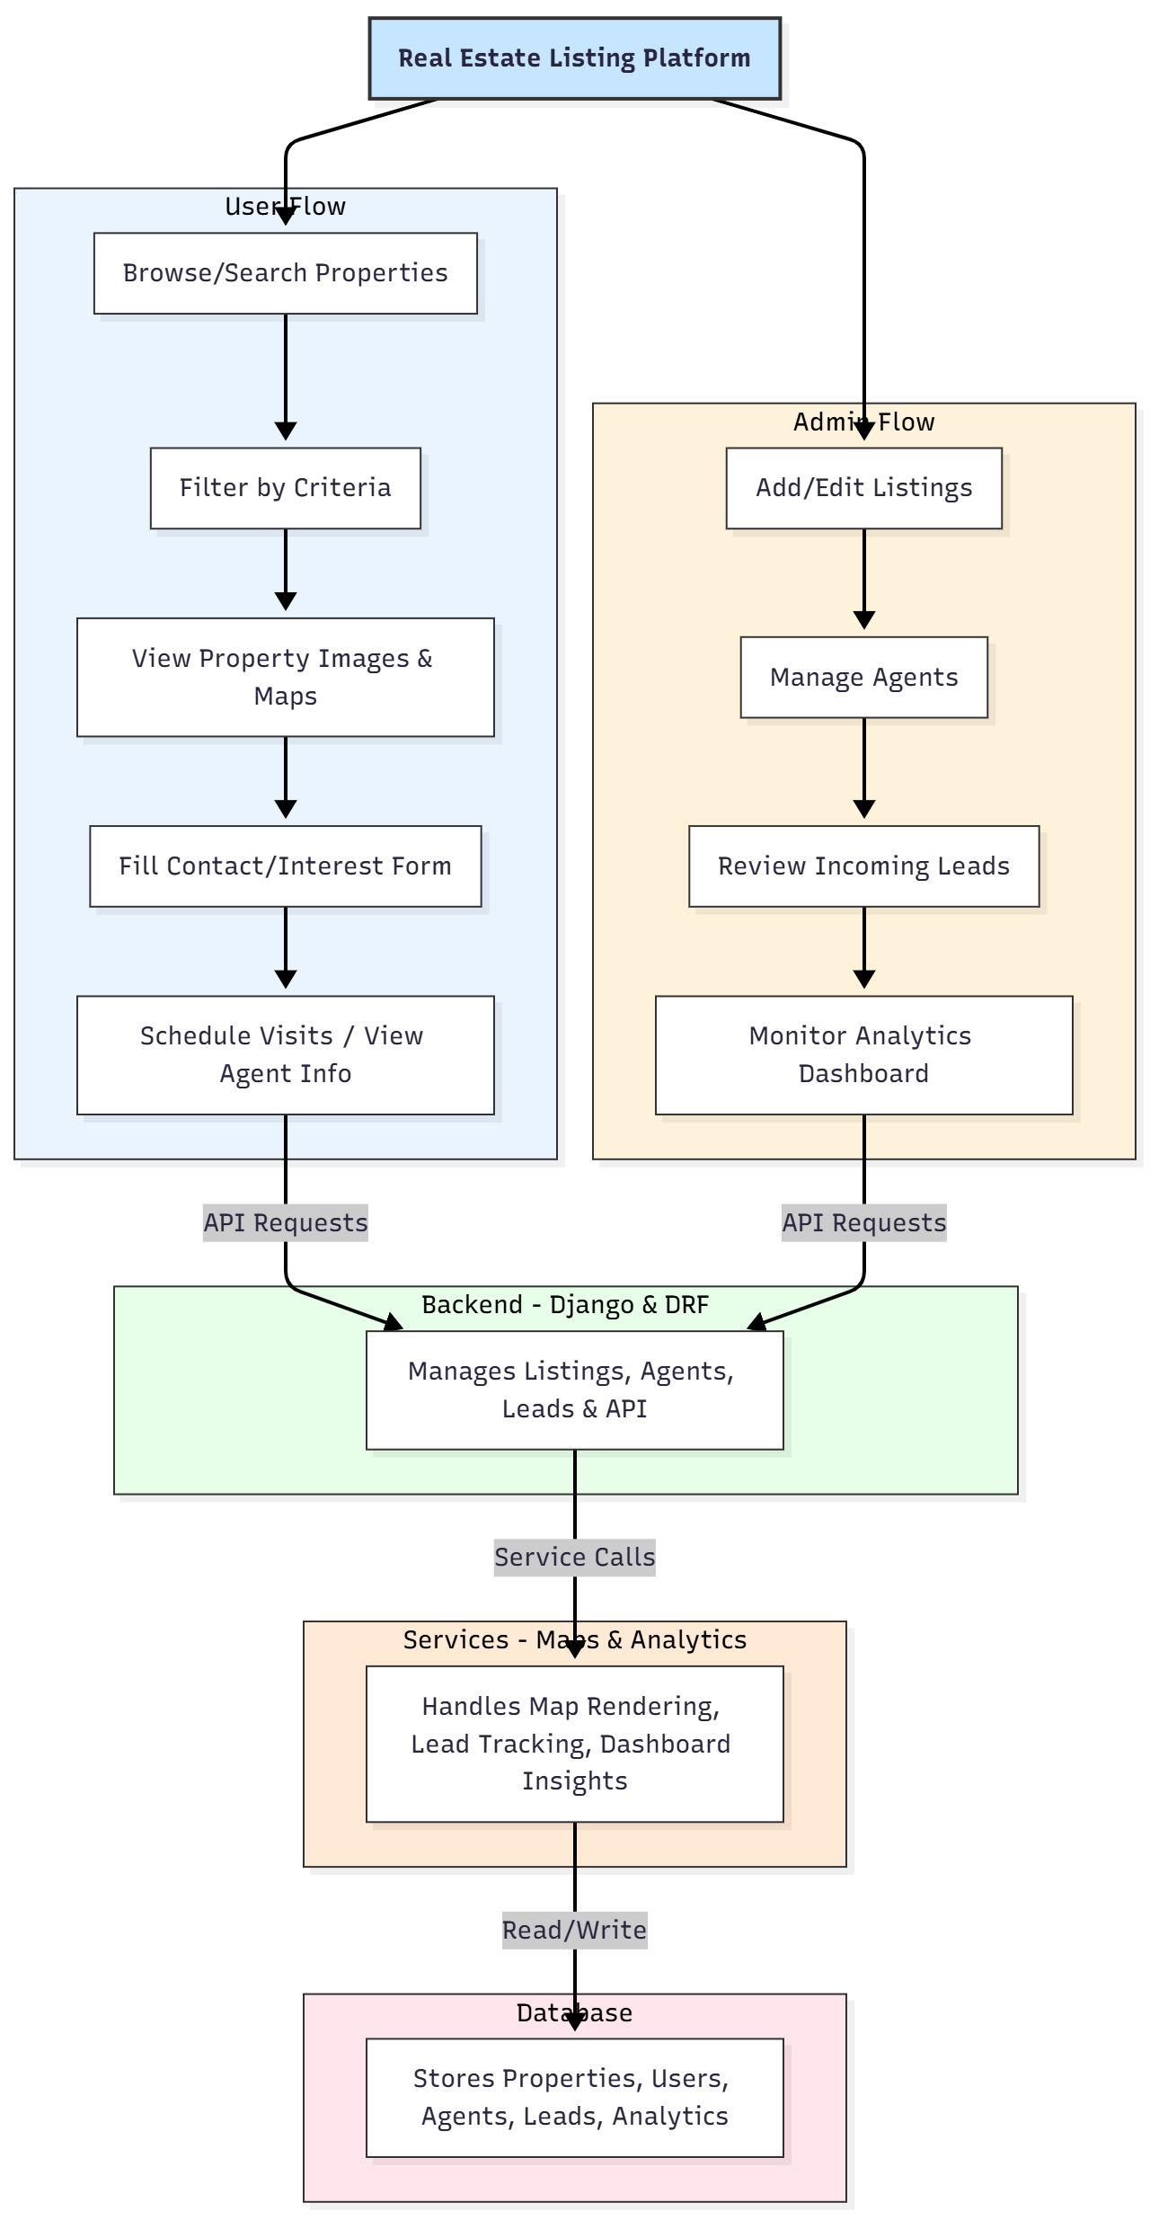

WORKING OF THE PROJECT:
Users start by browsing or searching for properties using filters such as price, type, location, and amenities. Property listings display images, map locations via Leaflet, and agent details. Users can submit interest forms or schedule visits directly through the platform. The backend validates requests, manages data storage, and communicates with the frontend via APIs. Administrators add or edit property listings, manage agent profiles, monitor incoming leads, and track dashboard analytics. The services module handles map integration, analytics, and reporting. All data is securely stored in a structured database, ensuring reliability, transparency, and efficient management..

SOFTWARE REQUIREMENT:
- Backend:
  - Python 3.x
  - Django
  - Django REST Framework
  - SQLite/PostgreSQL
- Frontend:
  - Node.js and npm
  - React.js
  - Axios
- Development Tools:
  - Visual Studio Code
  - Postman (for testing APIs)
  - Git/GitHub (for version control)
- Server/Deployment (Optional):
  - Gunicorn, Nginx, or Heroku/AWS for hosting

ADVANTAGES OF THE PROJECT:

• Interactive property search with filters and maps.
• Lead collection through contact and interest forms.
• Admin dashboard for managing listings, agents, and analytics.
• Easy scheduling and agent contact for prospective buyers/renters.
• Secure and scalable architecture.
• Centralized system for property listings and transactions.
• Real-time analytics for business performance tracking.
• Enhances efficiency for agents and convenience for users.

APPLICATIONS OF THE PROJECT:
• Real estate agencies and brokers.
• Property rental and sales platforms.
• Residential and commercial property portals.
• Individual agents managing multiple listings.
• Property comparison and information services.

REFERENCES:

- Django REST Framework Documentation — Django Software Foundation. Django Documentation. Available: https://docs.djangoproject.com/
- Django REST Framework. DRF Documentation. Available: https://www.django-rest-framework.org/
- React. React Official Documentation. Available: https://reactjs.org/docs/getting-started.html
- Redux. Redux Documentation. Available: https://redux.js.org/introduction/getting-started
- PostgreSQL Global Development Group. PostgreSQL Documentation. Available: https://www.postgresql.org/docs/
- MySQL. MySQL Reference Manual. Available: https://dev.mysql.com/doc/
- Git. Git Documentation. Available: https://git-scm.com/doc
- Node.js. Node.js Documentation. Available: https://nodejs.org/en/docs/
- Axios. Axios Documentation. Available: https://axios-http.com/docs/intro
- Socket.io Documentation – https://socket.io/docs/

